**Q&A visualization**

**Introduction**

The remarkable analytical capabilities of Microsoft Power BI and its AI-driven visualizations have captured the attention of numerous individuals at Adventure Works. They are interested in using it, but because of the technical aspect, feel it would be challenging to learn how to create a report. Kai, an experienced data analyst points out the **Q&A** visualization tool in Power BI that can transform natural language into reports.

But how does the **Q&A** visualization work? And how can it help inexperienced users build reports?

**What is the Q&A visualization?**

The **Q&A** visual in Power BI is an advanced natural language processing feature that allows users to directly query and explore their datasets using everyday language. Using underlying semantic models and AI algorithms, the **Q&A** Visual interprets and understands user input, transforming it into structured queries that retrieve relevant data points from the dataset. It then dynamically generates interactive visualizations that best represent the answers to these queries, enabling users to rapidly gain insights without requiring a deep understanding of the underlying data structure or complex query languages.

Imagine having a conversation with your data. Instead of sifting through rows and columns, you can simply type in natural language queries and watch as Power BI dynamically generates visualizations that answer your questions. This revolutionary approach bridges the gap between data experts and non-technical users, enabling everyone to harness the power of data analytics.

**Basic Q&A components and commands**

Before delving into the utilization of the **Q&A** visualization, let’s look at the visual’s four core components:

* **Q&A question field**: This is the main field, where you type a natural language question in this box to see possible answers and suggestions from Power BI.
* **Suggestions**: An automatically generated list of question suggestions appears to assist
* **Convert icon**: Select this icon to convert the Q&A visual into a standard visual adding it to your report.
* **Gear icon**: Select this icon to open the **Q&A** **Tooling** pane, which allows you to configure the underlying natural language engine to your preferences.

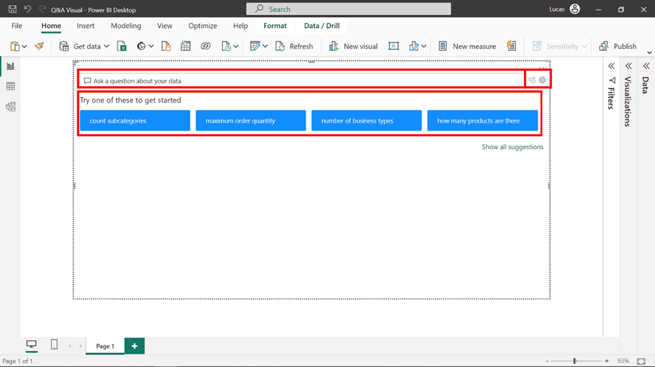

The **Q&A** visualization has a versatile collection of comprehension abilities, transforming words into insightful charts. Some of the main capabilities of the main natural language commands that the tool can interpret into results are:

* **Ask natural questions:** Which sales have the highest revenue?
* **Use relative date filtering:** Show me sales in the last year
* **Return only the top N:** Top 10 products by sales
* **Provide a filter:** Show me sales in the USA
* **Provide complex conditions:** Show me sales where product category is Category 1 or Category 2
* **Return a specific visual:** Show me sales by product as a pie chart
* **Use complex aggregations:** Show me median sales by product
* **Sort results:** Show me the top 10 countries/regions by sales ordered by country/region code
* **Compare data:** Show me the date by total sales vs total cost
* **View trends:** Show me sales over time

Before exploring the implementation of the **Q&A** visualization in detail, here are two examples of language turning into a Power BI visual:

* Show me the top 5 cities by sales amount in a funnel chart.
* Show me the order quantity by order date month where the product category is Accessories.

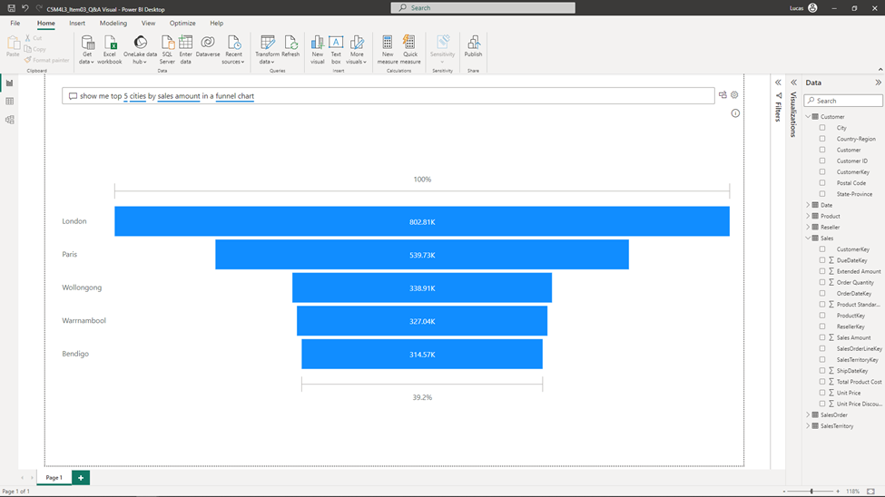

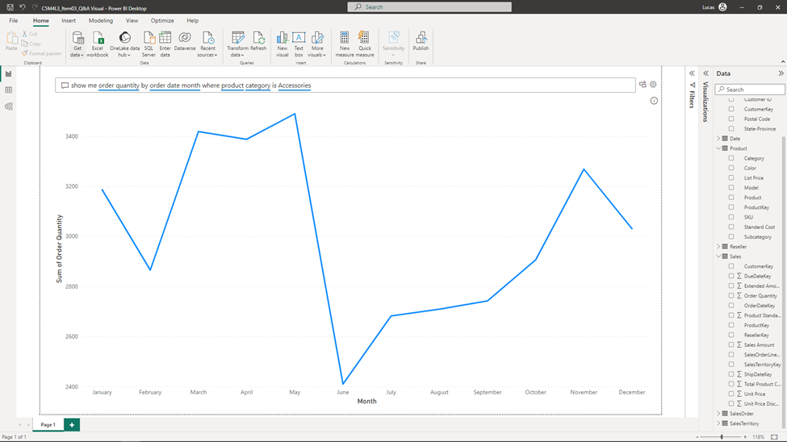

Now, let's discover how all these elements work together when crafting a Q&A visualization in Power BI.

**Implementation of the Q&A feature**

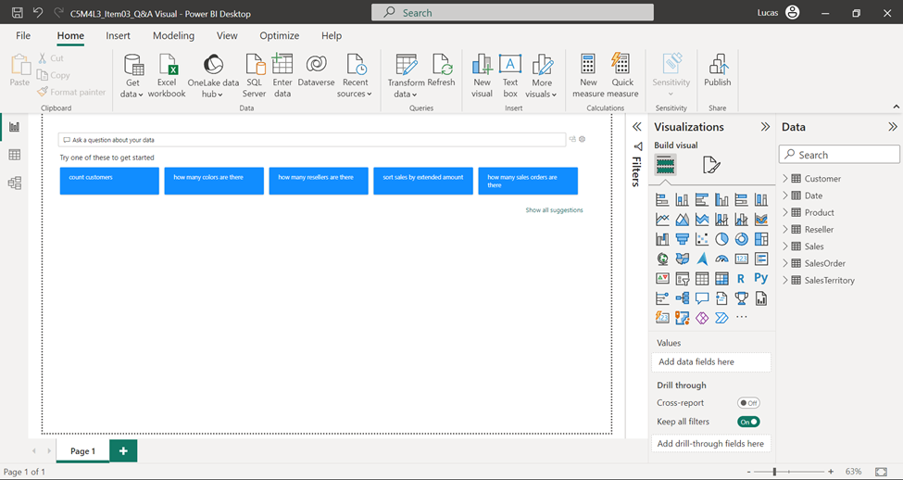

When creating a **Q&A** visualization, the **Question** field and a selection of suggestions appear below it. These suggestions are designed to guide you in formulating queries using natural language.

Let’s type a question for Power BI to see how it seamlessly transforms it into a graphical representation. Using the familiar Adventure Works dataset, we will structure a natural language query requesting a specific visualization with an aggregated measure, categorical axis, and a filter.

As you type your question, Power BI **Q&A** displays relevant autocomplete suggestions, like using a search engine. Note that the visualization underlines words as recognition feedback.

**Blue underline**

A solid blue underline indicates that the systems matched the word with the respective field.

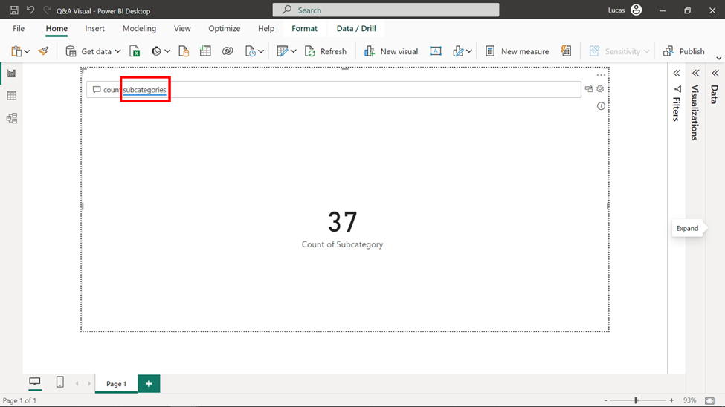

**Orange dotted underline**

An orange dotted underline indicates that the word used is vague or ambiguous. This could happen when using the word **date** in the question field when there are multiple date references, for example, **Order date**, **Shipping date,** or **Sales date** in the dataset.

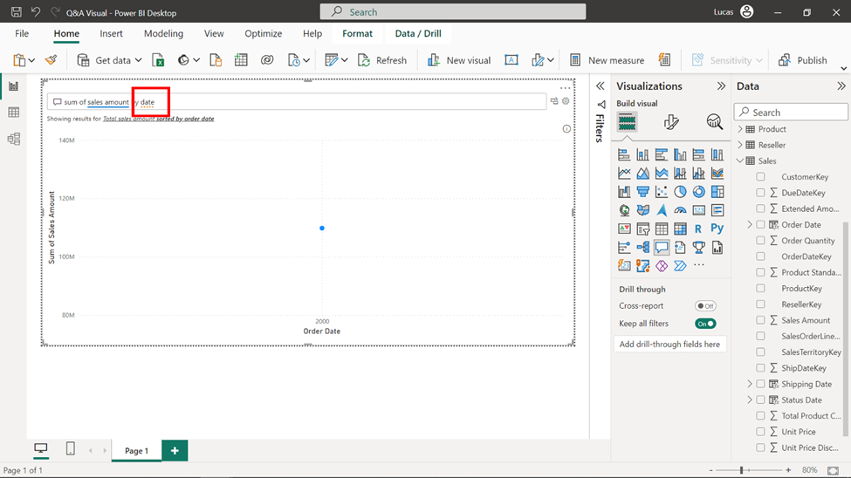

**Double red line**

The third and last indicator is a double red line, indicating that the word can’t be matched with a dataset field.

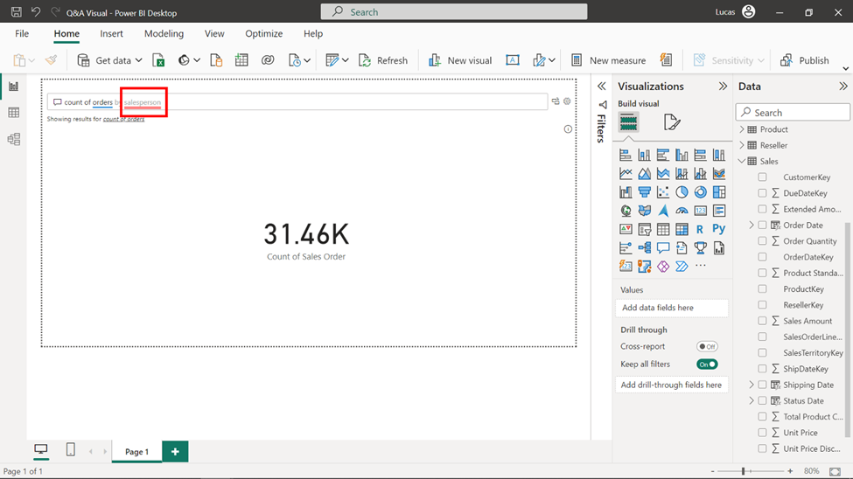

Here is an example of the visualization generated by entering the following question: ***count of orders per region clustered column chart with Internet channel****.* Note the generated visualization outcome when typing this sentence:

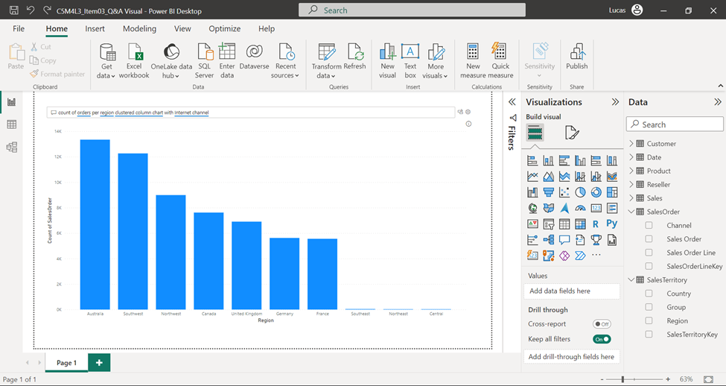

The **Q&A** visualization created the chart type suggested, included the aggregation measure of count in the **Orders** column and **Region** in its respective axis and even filtered by the column channel.

By selecting the gear button directly at the right end of the question field, you navigate to the deliberate **Q&A** settings. Let’s explore them one by one.

**Q&A setup configuration**

The Q&A visual presents a versatile range of configurations that directly enhance its language interpretation capabilities and improve communication with report users. Here are a few:

1. **Field synonyms**: This setting allows you to define synonyms or alternative names for fields in your dataset. By specifying synonyms, you enable Q&A to understand and interpret a variety of user inputs, increasing the accuracy of query interpretation.
2. **Review questions**: In this setting, you can review and manage questions that users have asked using the Q&A feature. It provides you with insights into user interactions and allows you to refine the system's understanding by improving its response to specific queries.
3. **Teach Q&A**: This setting enables you to train the Q&A system to better understand and answer specific questions. You can provide explicit phrasing examples for different types of queries, helping the system improve its response accuracy.
4. **Manage terms**: Here, you can manage and control how terms are interpreted in the Q&A feature. You can define terms that have specific meanings in your context and guide the system to accurately interpret user queries involving those terms.
5. **Suggest questions**: This setting uses user interactions to suggest new questions that could be added to the Q&A system. By analyzing user inputs, the system can recommend new questions to enhance the dataset's coverage.

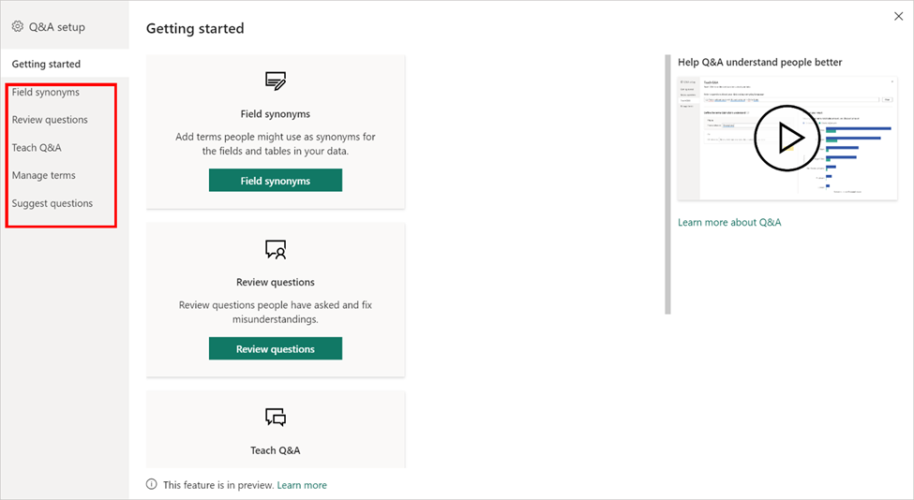

**Conclusion**

The **Q&A** visualization empowers both data analysts and newcomers to transform complex datasets into interactive insights. This tool bridges the gap between questions and visualizations, making data's potential accessible to all, and enabling a richer connection to one's data-driven journey.